Data Analytics
Study Notes
PART 1: STATISTICS AND DISTRIBUTIONS

1. Uniform Distribution
A uniform distribution means every possible value has the same chance of happening. Think of rolling a fair die: you can get 1, 2, 3, 4, 5, or 6, and each has the same chance of 1 out of 6 (about 0.167 or 16.7%).
If you draw this on a graph, it looks like a flat rectangle because no value is more likely than another. The formula for the probability at any point is:
f(x) = 1 / (b - a)
Here, "a" is the smallest value and "b" is the largest value. Between these two points, the probability is spread out evenly.
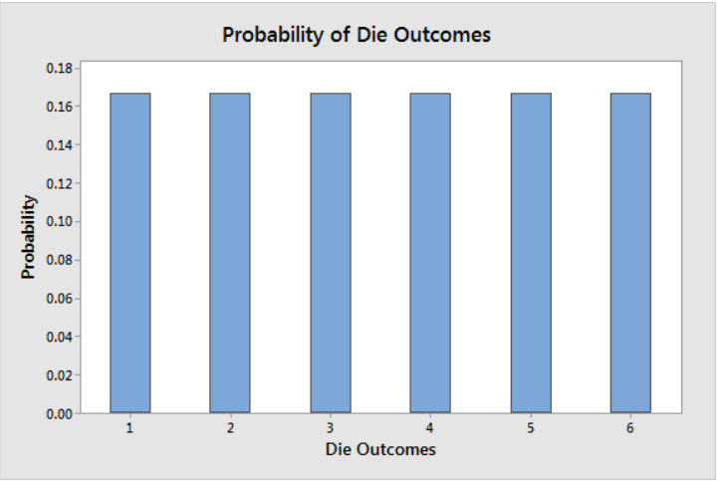
Figure 1: Bar chart showing equal probability (0.167) for each die outcome (1 to 6)

2. Left-Skewed Distribution (Negative Skew)
A left-skewed distribution is one where the long tail of the graph goes to the left side. Most of the data is on the right (higher values), but a few very low values pull the tail to the left.
This is also called negative skew. A simple example: if most students score very high on a test but a few score very low, the score data is left-skewed.
- The peak (most common values) is on the right side.
- The tail stretches out to the left.
- The mean (average) is usually lower than the middle value (median).
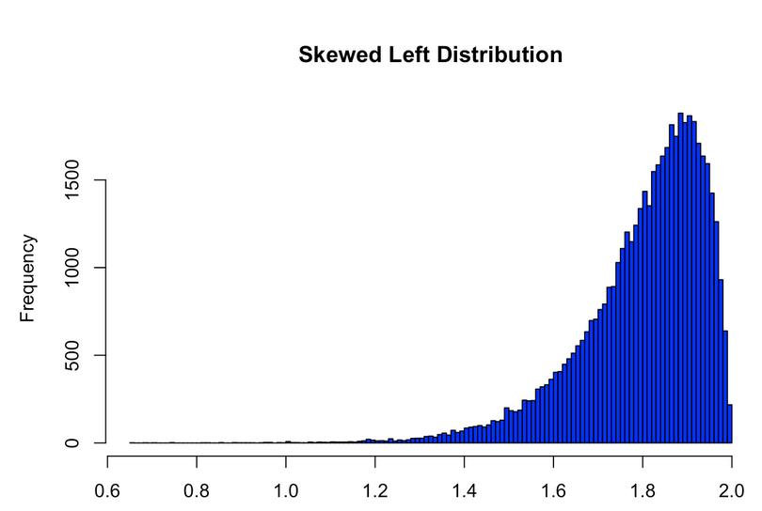
Figure 2: Left-skewed distribution - most data is on the right, with a long tail on the left

3. Normal Distribution (Bell Curve)
The normal distribution is the most common shape in statistics. It looks like a bell when drawn on a graph, which is why it is called a bell curve.
The key feature is that data is balanced perfectly on both sides of the middle (the mean). Values close to the mean appear most often, and values far from the mean appear less often.
- It is symmetric - the left side is a mirror of the right side.
- The mean, median, and mode are all at the same point (the center).
- About 68% of data falls within one step (standard deviation) from the center.
Example: The heights of 14-year-old girls, shown below, follow a normal distribution. Most girls are close to 1.512 meters tall, and very few are much shorter or much taller.
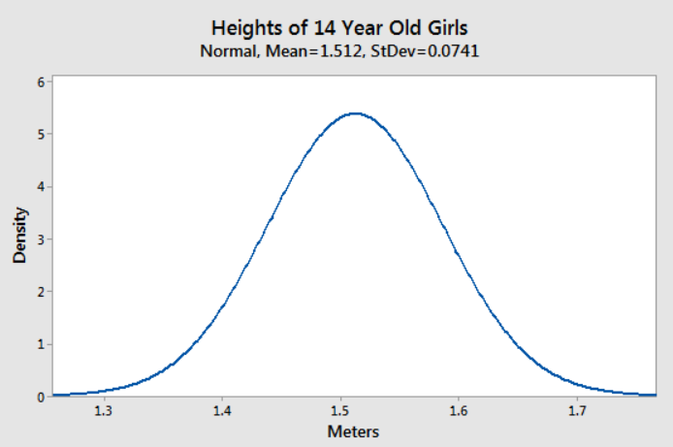
Figure 3: Normal distribution of heights of 14-year-old girls - a classic bell curve shape

4. Correlation
Correlation tells us whether two things (called variables) are related to each other. When one changes, does the other also change? There are three types of correlation:

4.1 Positive Correlation
When one variable goes up, the other also goes up. When one goes down, the other also goes down. They move in the same direction.
Example: As a person studies more hours, their exam score goes up. This is positive correlation. The correlation number is between 0 and +1. A value close to +1 means a very strong positive relationship.
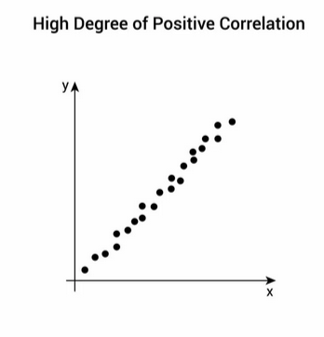
Figure 4: Positive correlation - dots move upward from left to right

4.2 Negative Correlation
When one variable goes up, the other goes down. They move in opposite directions.
Example: As the price of a product goes up, fewer people buy it. The correlation number is between 0 and -1. A value close to -1 means a very strong negative relationship.
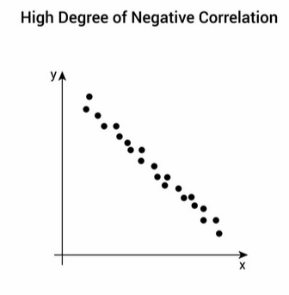
Figure 5: Negative correlation - dots move downward from left to right

4.3 No Correlation
There is no clear relationship between the two variables. One changing does not tell us anything about how the other will change. The dots on a graph appear scattered with no pattern.
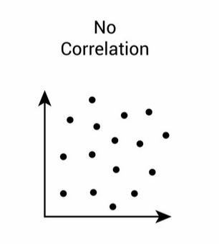
Figure 6: No correlation - dots are scattered randomly with no pattern

5. Linear vs. Non-linear Correlation

5.1 Linear Correlation
In linear correlation, the relationship between two variables follows a straight line. The linear correlation coefficient is a number that tells us how strong and in which direction this straight-line relationship is.
- A positive number means both variables increase together.
- A negative number means one goes up while the other goes down.
- A number close to 0 means there is little or no straight-line relationship.

5.2 Non-linear Correlation
In non-linear correlation, the two variables are related, but not in a straight line. The rate of change is not constant.
Example: When income increases by 20%, spending might increase by 5% sometimes, 10% other times, or 15% at other times. The change is not the same each time, which makes it non-linear.

PART 2: BUSINESS INTELLIGENCE AND ANALYTICS

6. Evolution of Decision Support and Analytics
The way businesses use data has changed a lot over the decades. Below is a simple timeline of how it developed from the 1970s to today:
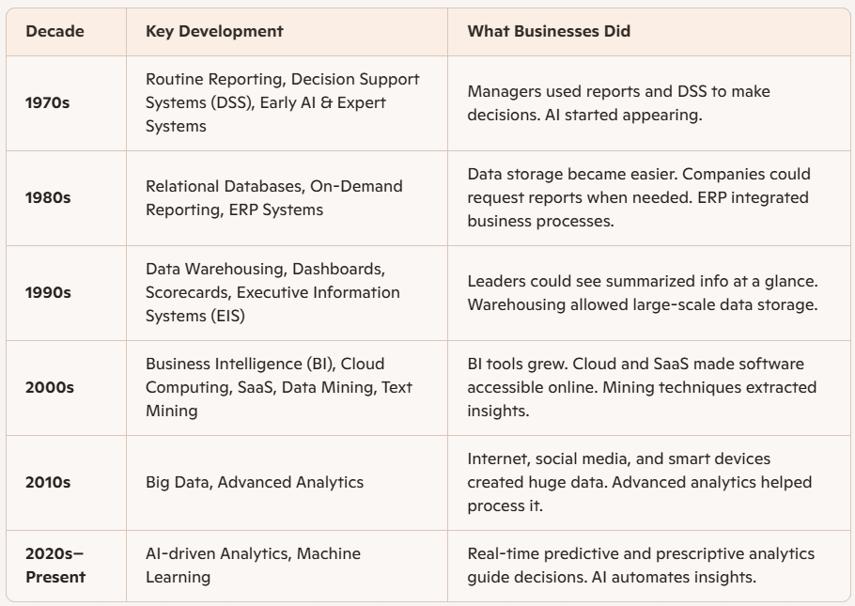
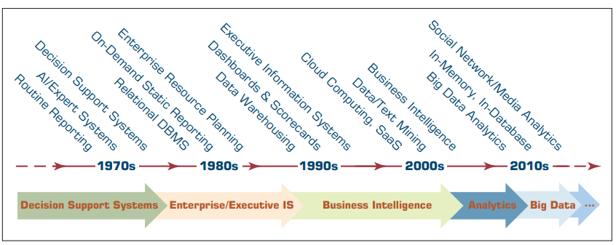
Figure 7: Timeline of evolution from Decision Support Systems (1970s) to Big Data Analytics (2010s)

7. The Rise of Big Data
Starting in the 2010s, the internet changed how data is created. New sources of data appeared everywhere: websites, social media, smart home devices, health monitors, and more.
This large wave of new data is called Big Data. It is called "big" not just because there is a lot of it, but also because it is fast, varied, and hard to handle with old tools.
To deal with Big Data, new technologies were created. For example, Hadoop with MapReduce allows processing of very large amounts of data across many computers at once. NoSQL databases store data in more flexible ways than traditional systems.
Social media is one of the most interesting and challenging new data sources. The data it produces is unstructured (not in neat tables or rows) and comes in very large amounts.

8. What is Business Intelligence (BI)?
Business Intelligence (BI) is a broad term that covers all the tools, systems, and methods used to collect, store, and analyze business data. The main goal of BI is to help people in a business make better decisions.
BI does this by:
- Giving decision makers easy access to data, sometimes in real time.
- Letting people explore and work with the data themselves.
- Turning raw data into useful information that leads to smart decisions.
The basic process of BI goes like this:
Data -> Information -> Decision -> Action
BI uses historical data (what happened in the past) and current data (what is happening now) to help managers understand situations and plan better for the future.

Assignment-01
- List three of the terms that have been predecessors of analytics.
- What was the primary difference between the systems called MIS, DSS, and Executive Support Systems?
- Did DSS evolve into BI or vice versa?

9. The Architecture of Business Intelligence
The BI architecture shows all the parts that work together to make Business Intelligence possible. Think of it as a map of how data travels from its source to a business decision.
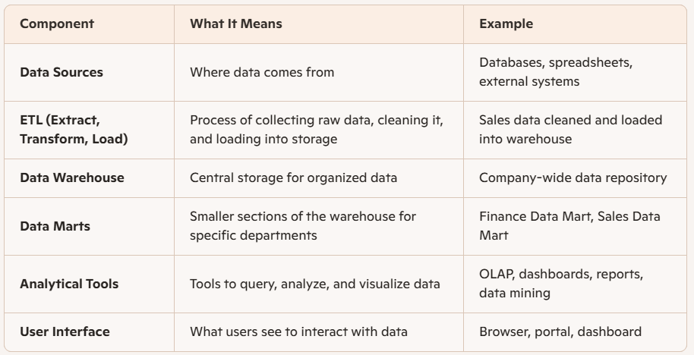

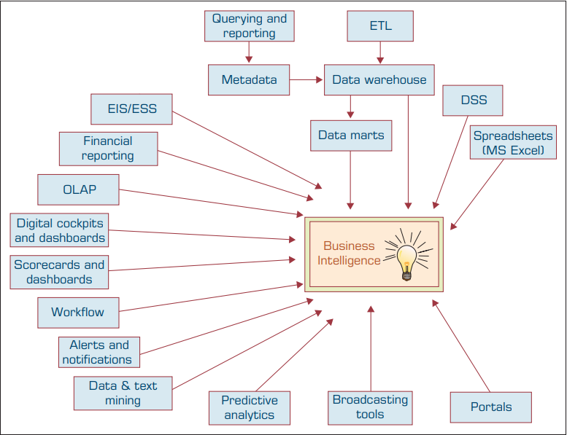
Figure 8: Architecture of Business Intelligence - how data flows from sources through the warehouse to business decisions

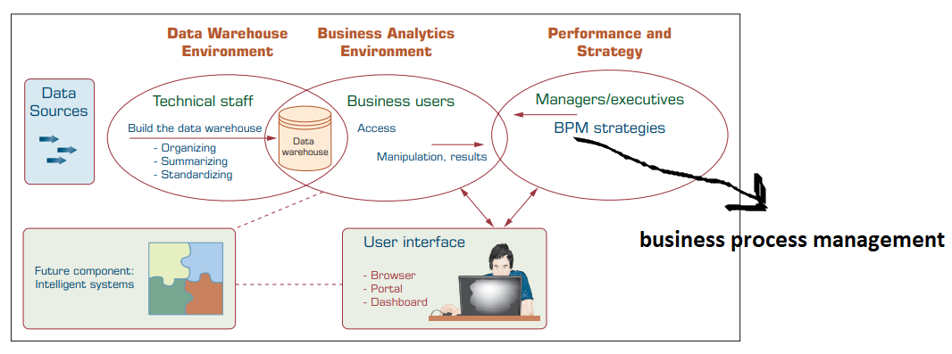
Figure 9: BI system showing Data Warehouse Environment, Business Analytics, and Performance and Strategy layers

Short Notes
Write short notes on:
- OLAP
- OLTP
- SCM/CRM
Case Study (Chapter 1): 1.1, 1.2, 1.3, 1.4, and 1.5

Self Study
- Is it a good idea to follow a hierarchy of descriptive and predictive analytics before applying prescriptive analytics?
- How can analytics aid in objective decision making?

10. Big Data: The 4 Vs
Big Data is described by four main characteristics, often called the "4 Vs":
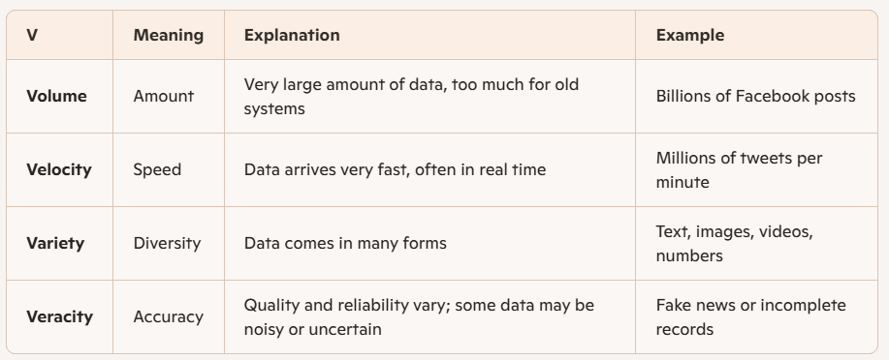
Together, these four features create the challenge - and the opportunity - of Big Data. When handled well, Big Data connects to Business Intelligence and Analytics to create smarter decisions.
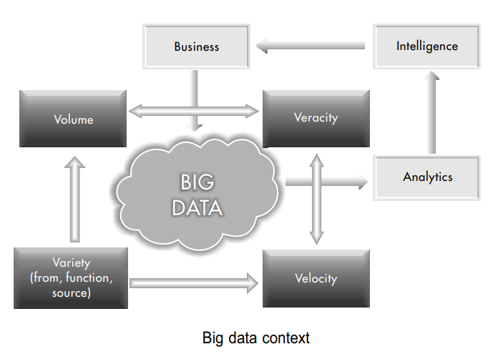
Figure 10: The Big Data context - Volume, Velocity, Variety, and Veracity feeding into Business Intelligence and Analytics

11. The Analytics Ecosystem
An analytics ecosystem is the full network of people, organizations, and tools that work together around a data-driven organization. It is not just about software - it includes many different players.

Component | What It Means | Role/Example
Analytics User Organization | The business using data | Center of the ecosystem
Data Generation Infrastructure Providers | Tools/systems that create and collect data | Sensors, websites, social media platforms
Data Management Infrastructure Providers | Keep data stored and organized | Database systems
Data Warehouse Providers | Store large amounts of cleaned data | Central repositories for analysis
Analytics-Focused Software Developers | Build tools for analyzing data | OLAP tools, dashboards
Application Developers | Create everyday business software | ERP, CRM systems
Academic Institutions & Certification Agencies | Train people and set standards | Universities, training centers
Regulators & Policy Makers | Create rules for data use | Government agencies
Analytics Industry Analysts & Influencers | Study and share analytics trends | Market research firms
Middleware Providers | Connect different systems with software | Integration tools
Data Service Providers | Offer data as a service | External data vendors

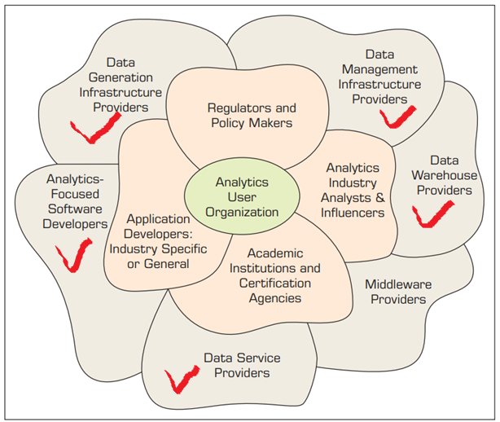
Figure 11: The Analytics Ecosystem - the network of organizations and providers surrounding an analytics user organization

অংশ | বাংলায় ব্যাখ্যা | কাজ
Analytics User Org | ডেটা ব্যবহারকারী প্রতিষ্ঠান | সিদ্ধান্ত নেয়
Data Generation | ডেটা তৈরি | সেন্সর, অ্যাপ
Data Management | ডেটা সংগঠন | ডেটাবেস
Data Warehouse | বড় ভাণ্ডার | বিশ্লেষণের জন্য
Analytics Software Dev | বিশ্লেষণী টুলস | BI Tools
Application Dev | ব্যবসার অ্যাপ | ERP, CRM
Academic & Certifiers | প্রশিক্ষণ ও মান | কোর্স, সার্টিফিকেট
Regulators | নিয়ম-কানুন | ডেটা আইন
Analysts & Influencers | ট্রেন্ড গবেষণা | রিপোর্ট, ব্লগ
Middleware | সংযোগকারী সফটওয়্যার | সিস্টেম লিঙ্ক
Data Service Providers | ডেটা সেবা | API, ডেটা ফিড

12. Overview: Business Intelligence and Analytics
The full subject of Business Intelligence and Analytics is organized into several major areas:
- Introduction (Chapter 1): Overview of Business Intelligence, Analytics, and Data Science.
- Descriptive Analytics (Chapters 2 and 3): Understanding what has already happened. Covers the nature of data, statistical modeling, visualization, and data warehousing.
- Predictive Analytics (Chapters 4 and 5): Predicting what might happen next. Covers data mining, text mining, web analytics, and social media analytics.
- Prescriptive Analytics (Chapter 6): Deciding what action to take. Covers optimization and simulation.
- Future Trends (Chapters 7 and 8): Big Data concepts and tools, future trends in analytics, privacy, and management considerations.
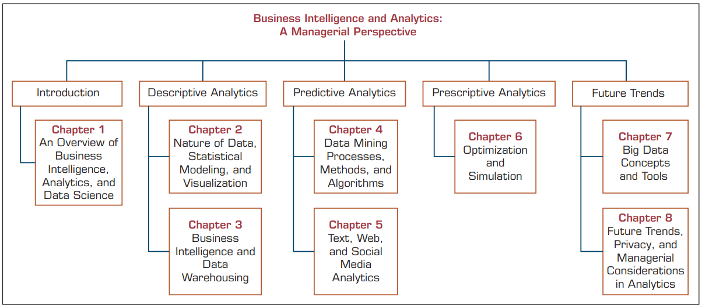
Figure 12: Structure of Business Intelligence and Analytics - from Introduction through Descriptive, Predictive, Prescriptive Analytics to Future Trends

Quick Summary
Part 1 covered how data can be spread in different patterns (uniform, skewed, or normal), and how two variables can be related to each other (positive, negative, or no correlation, in linear or non-linear ways).
Part 2 covered how businesses use data to make decisions. Business Intelligence (BI) evolved from simple reporting in the 1970s to today's Big Data era, where massive amounts of fast, varied data are processed using advanced tools to help organizations act smarter and faster.

